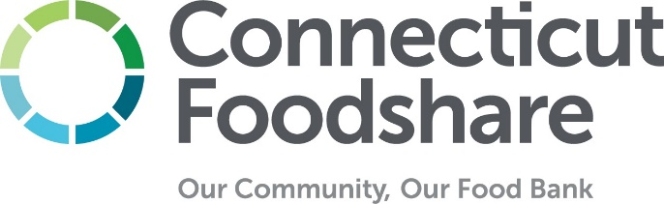

Recall Procedure for Partner Programs
This is an optional tool for partner programs to use and adapt for their internal recall procedures. This information should be shared with all key staff and volunteers involved with food preparation and distribution.

Individual(s) Responsible for Tracking Recalls at this Location

Lead Name & Contact Information:

_____________________________________________________________________

Back-Up Name & Contact Information:

_____________________________________________________________________

Have they subscribed to USDA recall alerts? Here

Have they subscribed to the Connecticut Foodshare partner newsletter? Here

Guidance from Connecticut Foodshare
Connecticut Foodshare uses notifications from Feeding America, the United States Department of Agriculture (USDA), the Food & Drug Administration (FDA), and local news sources to keep updated on food recalls. Connecticut Foodshare researches the type of product, the distribution area, and the likelihood of the network receiving recalled product.

Connecticut Foodshare issues recall information only for product we have record of distributing from our inventory. Our inventory system allows us to trace recalls for items we receive in large lots; we are not able to track recall information for products that are donated in smaller, individual quantities (such as through community food drives or a mixed bin from grocery stores). When Connecticut Foodshare issues a recall notice, partner programs will receive an email notification to the primary contact in our records. The recall notice from Connecticut Foodshare will include directions on what to do if you find the recalled product in your inventory and a flyer that you should post and/or share with your guests at your next distribution.

Partner programs should have one person assigned to reviewing recalls on a regular basis. You can monitor product recalls from the USDA and FDA on this website: https://www.foodsafety.gov/recalls-and-outbreaks and by signing up for emails from the USDA here: USDA Recalls and Alerts. Connecticut Foodshare should not be your only or primary source of recall information.

If you find recalled product in your inventory, here are some recommended steps:
- If you find the recalled product in stock, separate it immediately and do not distribute it.
- Attach HOLD tags to the recalled product in your inventory until you can properly dispose of it.
- Notify relevant staff and volunteers at your program so they can watch for the recalled product in any upcoming food donations you may receive from the community. Consider having a bulletin board near your inventory to post recall notices.
- Notify visiting neighbors so they can be made aware of the recall and what to do if they have recalled product at home. This can be done at a minimum by posting a recall notice in a visible area during upcoming distributions.
- Save records of any recall notices you issue for the current year

Additional Guidance from this Site:

Fill in any additional instructions for your program staff and volunteers here

Recall Log
Item Being Recalled | Date of Recall | Reason | Action Taken | Signature

